COMP 3270 Assignment 4 (100 points)

**Due by 11:59PM on Friday, July 30th, 2021**

Instructions:

1. Late submissions **will not** be accepted unless prior permission has been granted or there is a valid and verifiable excuse.
2. Think carefully; formulate your answers, and then write them out concisely using English, logic, mathematics and pseudocode (no programming language syntax).
3. Type your final answers in this Word document.
4. Don’t turn in handwritten answers with scribbling, cross-outs, erasures, etc. If an answer is unreadable, it will earn zero points. **Neatly and cleanly handwritten submissions are acceptable**.

**1. (15 points)** Show d and π values that result from running Breadth First Search on the directed graph below using vertex 3 as the start node.

d=∞

d=3

π =nil

π =4

d=0

π =nil

d=1

π =3

π =5

π =3

d=2

d=1

**2. (10 points)** Show how Depth First Search works on the graph below by marking on the graph the discovery and finishing times (d and f) for each vertex and the classification of each edge. Assume that the for loops in DFS and DFS-VISIT consider vertices alphabetically.

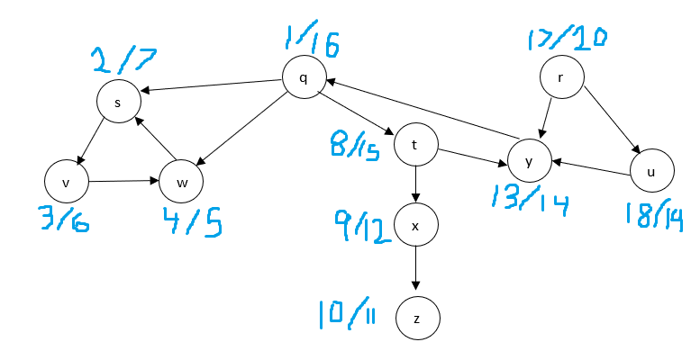

**3. (15 points)** List the vertices of the graph below in Topological Order, as produced by the Topological Sort algorithm. Assume that the for loops in DFS and DFS-VISIT consider vertices alphabetically.

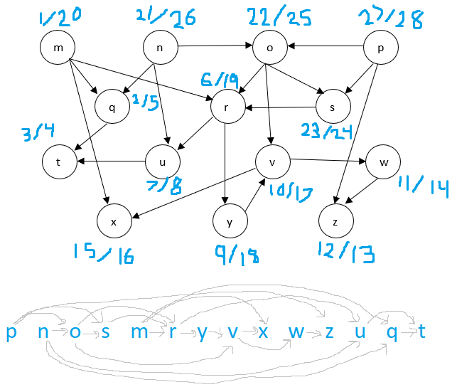

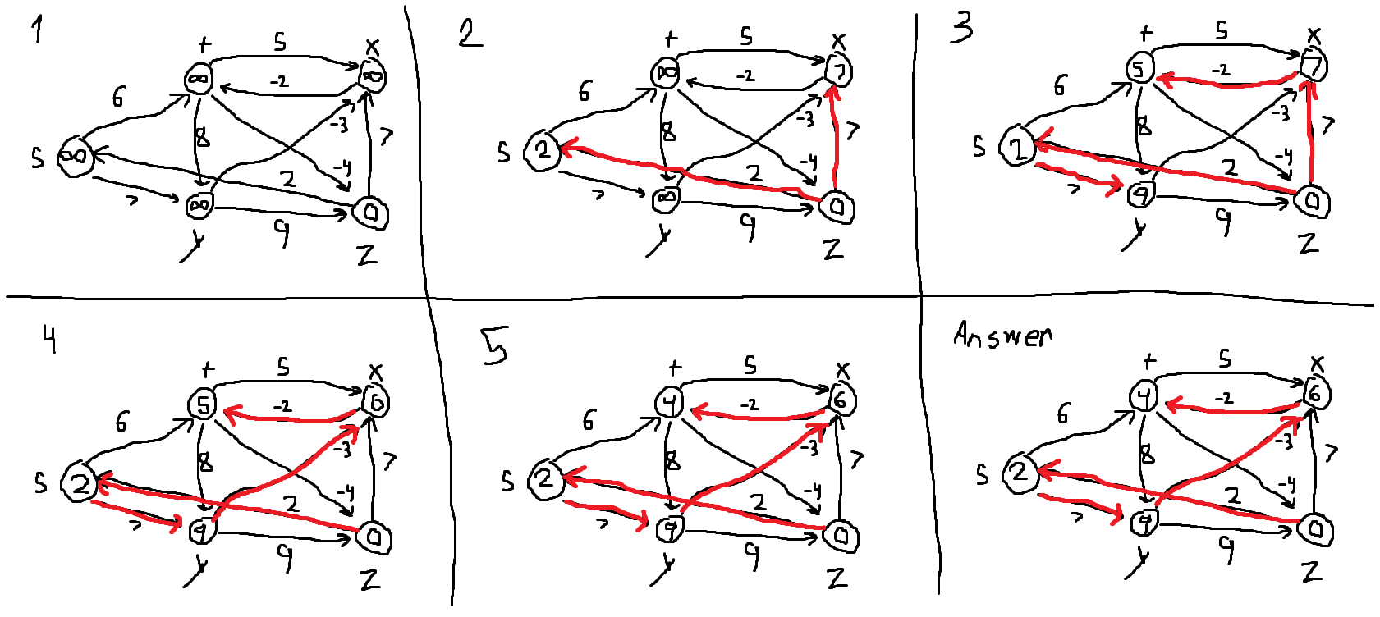**4. (15 points)** Do Problem 24.1-1 (p. 654) (you do not have to do the last part, i.e., running the algorithm again after changing an edge weight).

**5. (15 points)** Do Problem 24.2-1 (p. 657). Show the results similar to Fig. 24.5.

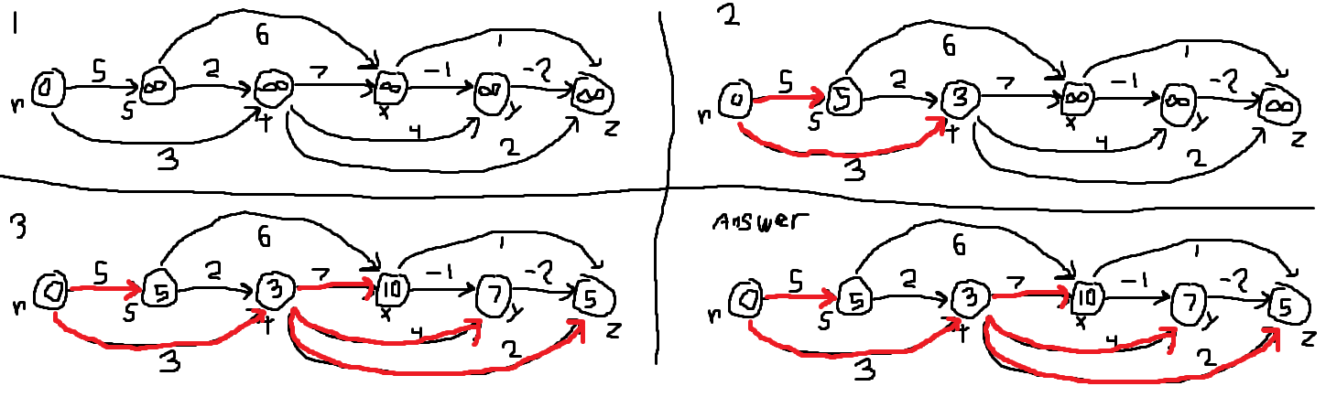

**6. (20 points)** Do Problem 24.3-1 (p. 662).

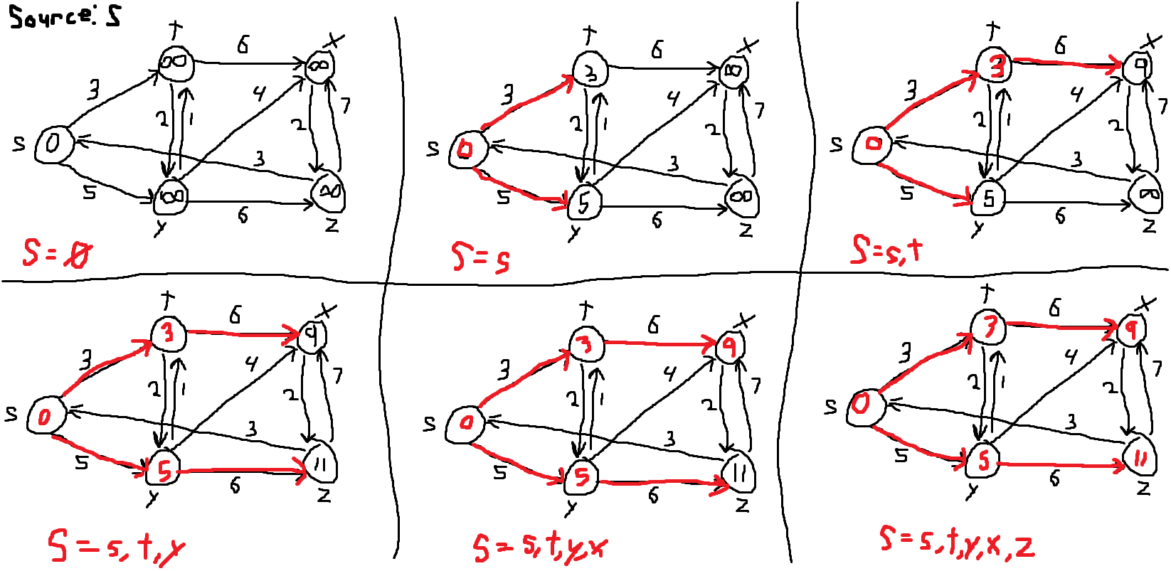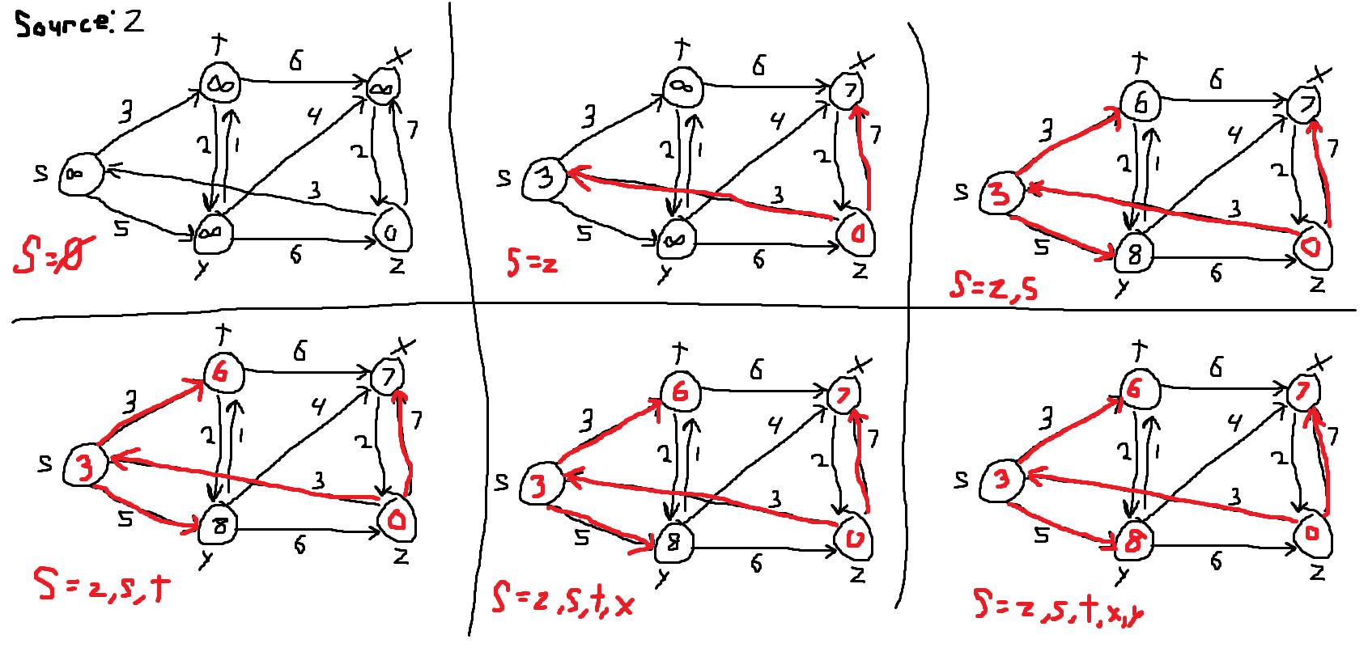

**(7) (10 points)** Supposethat a graph G has a Minimum Spanning Tree (MST) computed. How quickly can we update the MST if we add a new vertex and incident edges to G. Propose and outline a strategy and present an algorithm (you can reuse graph algorithms covered in class as building blocks as part of your solution) and evaluate its asymptotic complexity.

We can select the lowest edge incident on the new vertex and then use it to connect the new vertex to the existing MST. This step takes constant time. For each remaining edge, we can first include it in the MST, inducing a cycle, and then use DFS to find the resultant cycle. Once the cycle is detected, the edge with the largest weight is removed from the set of edges in the cycle. If the number of edges incident edges is k, then the cost of detecting cycle, induced by k-1 edges (k-1)(V+E), where (V+E) is the cost of running DFS on a graph G = (V,E). So, the overall cost is O(k(V+E)). If k is constant, then the asymptotic expression reduces to O(V+E), which is linear in the size of the graph.